# How to link your Cards to Alipay?

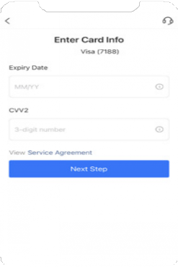

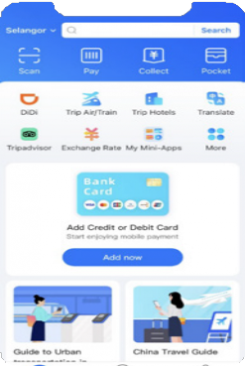







STEP 1

STEP 2

STEP 3

Tap “Add Now” and follow the on-page prompts to enter your card details

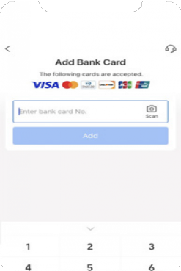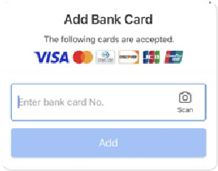

Enter your bank card number and click “Add”

Fill in the required details, then click “Next Step”

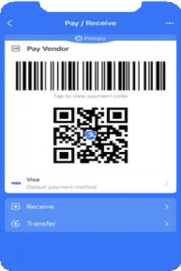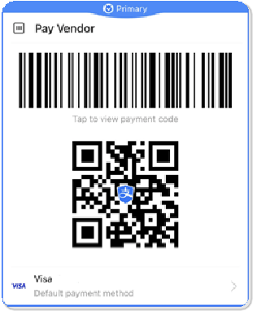

STEP 4

STEP 5

Success! Your UnionPay Cards is now linked to Alipay

Begin using Alipay to pay or receive money

# How to pay using Alipay?

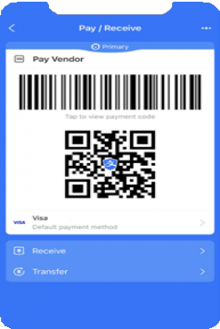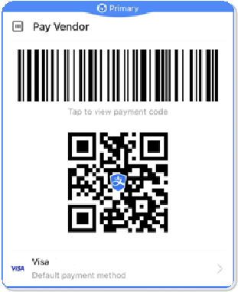

Present & Pay

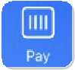

 Click on “Pay/Receive” on the Alipay Homepage

 Present the payment QR code

to the merchant for scanning



Scan & Pay

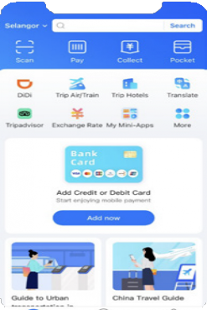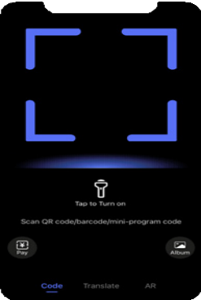

 Click on “Scan” on the Alipay Homepage

 Scan the merchant’s payment QR code & enter the payment amount

# w to add your UnionPay Cards to WeChat Pay?

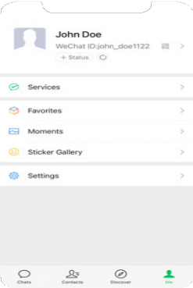

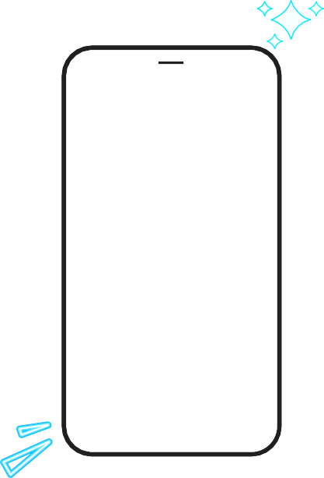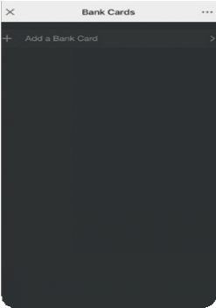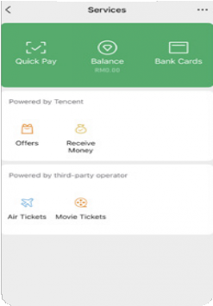

STEP 1

STEP 2

STEP 3

Open the “Me” tab & select “Services”

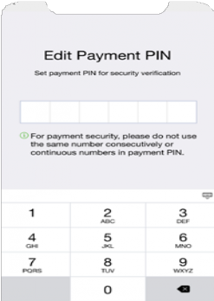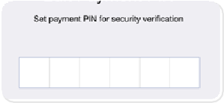

Click “Bank Cards” to link your UnionPay Cards

Select “Add a Bank Card”



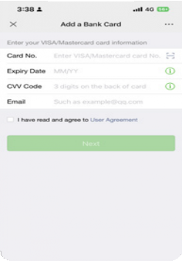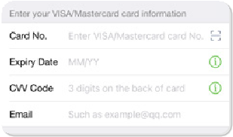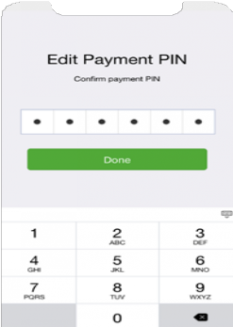

STEP 4

STEP 5

STEP 6

Fill in the required details

Set your 6-digit

payment PIN

Conﬁrm your 6-digit payment PIN

# How to change your Wallet Region from Malaysia to China Mainland?

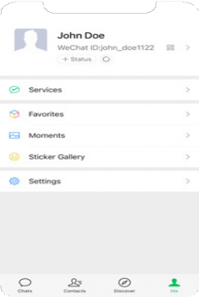

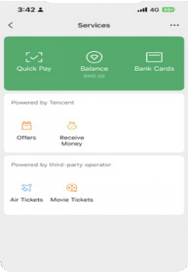

STEP 1

STEP 2

Open the “Me” tab & select “Services”

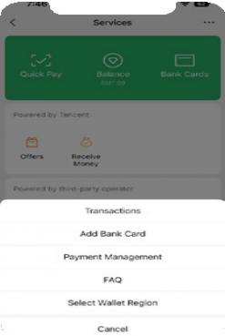

Click on the icon at the top right

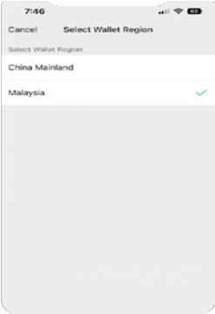

STEP 3

STEP 4

Click on “Select Wallet Region”

Click on “China Mainland”

# How to top up your WeChat wallet?

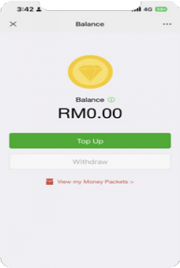









STEP 1

STEP 2

STEP 3

Open the “Me” tab & select “Services”

Click on “Balance”

Click “Top Up”



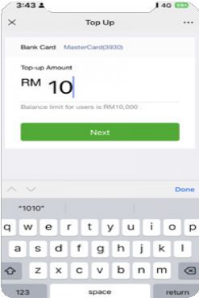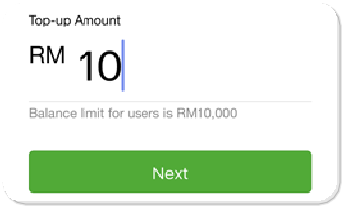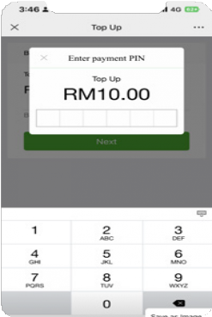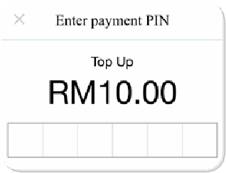

STEP 4

STEP 5

Fill in the amount (e.g., RM10.00)

Key in your 6-digit payment PIN to complete the top-up

# How to pay using your WeChat Pay?



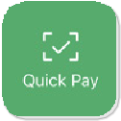

STEP 1

STEP 2

Open the “Me” tab & select “Services”

Click “Quick Pay”

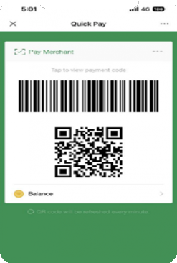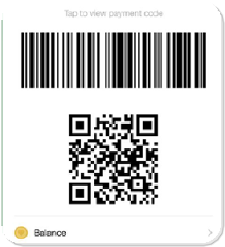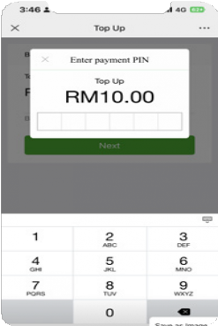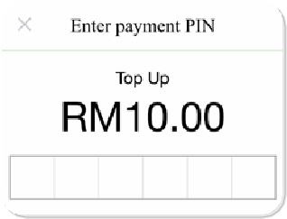

STEP 3

STEP 4

The merchant scans your QR code to complete the payment

Enter a 6-digit payment PIN (if prompted)